**EDUCATION**

Seton Hill University (2020 - 2022)

Area of study: Bachelor in Fine Arts (B.F.A) for Graphic Design with an Animation focus

GPA Average: 3.44

Associate’s at Westmoreland County Community College (2018 - 2020)

Class of 2018, Connellsville Area Senior High School

**GENERAL WORK EXPERIENCE**

In-Game Pixel Artist for Stomp Party (Larsonsoft, LLC.) (Oct. 2022 - present)

Biography and Art Description Writer for Art Authority (May 2022 - Aug. 2022)

Front-End Associate at Walmart (Oct. 2021 - Dec. present)

Freelance Commission Artist (Digital & Pixel Art) (July 31st, 2021 - present)

Front-End Associate at Martin’s (Sept. 2018 - Oct. 2021)

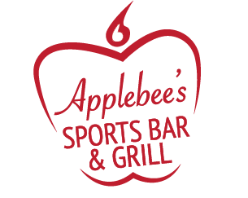

**GRAPHIC DESIGN EXPERIENCE**

Branding Class at Seton Hill University: Rebranded Applebee’s,

including a new logo, new style guide, and a more-focused

business strategy that better defines their values and competition.

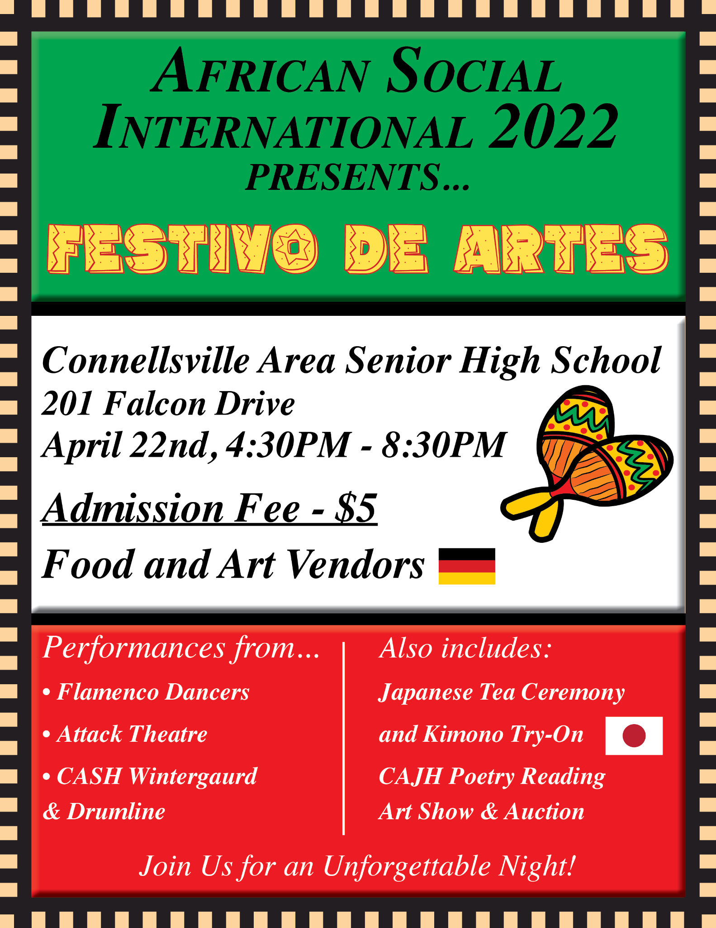

Took 9+ Classes for learning how to use Adobe applications

Volunteer Work for Connellsville Area Senior High: I communicated

with my former art teacher to fit everything she wanted in fundraising

event posters.

Skills: Infographics, Video Making, G-Suite, Photography, Writing, Social Media, Communication

Proficient with: Photoshop, InDesign, Illustrator, Premiere Pro, Animate, After Effects

**HONORS, AWARDS, & ACHIEVEMENTS**

NAHS (National Art Honors Society) Inductee Twice (2016 - 2017) & (2017 - 2018)

4-Time Dean’s Lister (2 Fall and Spring Semesters at WCCC)